
St. Gregory’s Catholic Primary School
Together, in Jesus, we Love, Learn, Create and Celebrate!

‘I praise you God for I am fearfully and wonderfully made.’
(Psalm 139:14)

No Outsiders

At St. Gregory’s Catholic Primary School, our commitment to nurturing the whole child is at the heart of everything we do. Our Fullness of Life – Personal Development Curriculum ensures that each pupil is supported in growing into a confident, compassionate individual who is ready to make a positive contribution to the world.
Our Fullness of Life offer is built around five key pillars:
- myHappymind+ – promoting wellbeing, resilience, and self-esteem
- Social Signature – developing character through service, leadership and community
- No Outsiders – teaching inclusion and respect for diversity in line with the Equality Act 2010
- A Journey in Love – our Relationships and Sex Education programme
- Pupil Experiences and Leadership – enriching personal growth through real-world opportunities
Together, these strands provide a values-driven and holistic approach to personal development, grounded in Catholic principles and British values.
At St. Gregory’s Catholic Primary School, we aim to teach children to recognise and celebrate difference. No Outsiders is a programme that helps children understand diversity and inclusion by exploring different groups of people through age-appropriate storybooks. The programme supports the teaching of the protected characteristics outlined in the Equality Act 2010, including race, religion, gender, disability, and more. Through these lessons, we ensure every child knows they belong, that difference is something to be respected, and that no matter who you are—you are welcome in our school. This inclusive ethos underpins everything we do and supports our commitment to fostering equality, empathy, and community cohesion.

To further support staff in delivering this element of our Fullness of Life curriculum, the following overview explains the principles behind the No Outsiders programme and its foundation in the Equality Act 2010.

No Outsiders
The Equality Act 2010: British law
Difference is protected under British law. There are very clear aims in the Equality Act that provide guidance for schools. As public bodies, we need to:
- Have due regard to the need to eliminate discrimination
- Advance equality of opportunity
- Foster good relations between different people when carrying out their activities
And who are those different people? The Equality Act references nine ‘protected characteristics’; these are groups of people. No one should face discrimination because of:
- Race
- Religion
- Sex
- Gender reassignment
- Age
- Disabilities
- Sexual orientation
- Pregnancy or maternity
- Marriage or civil partnership

Overview:
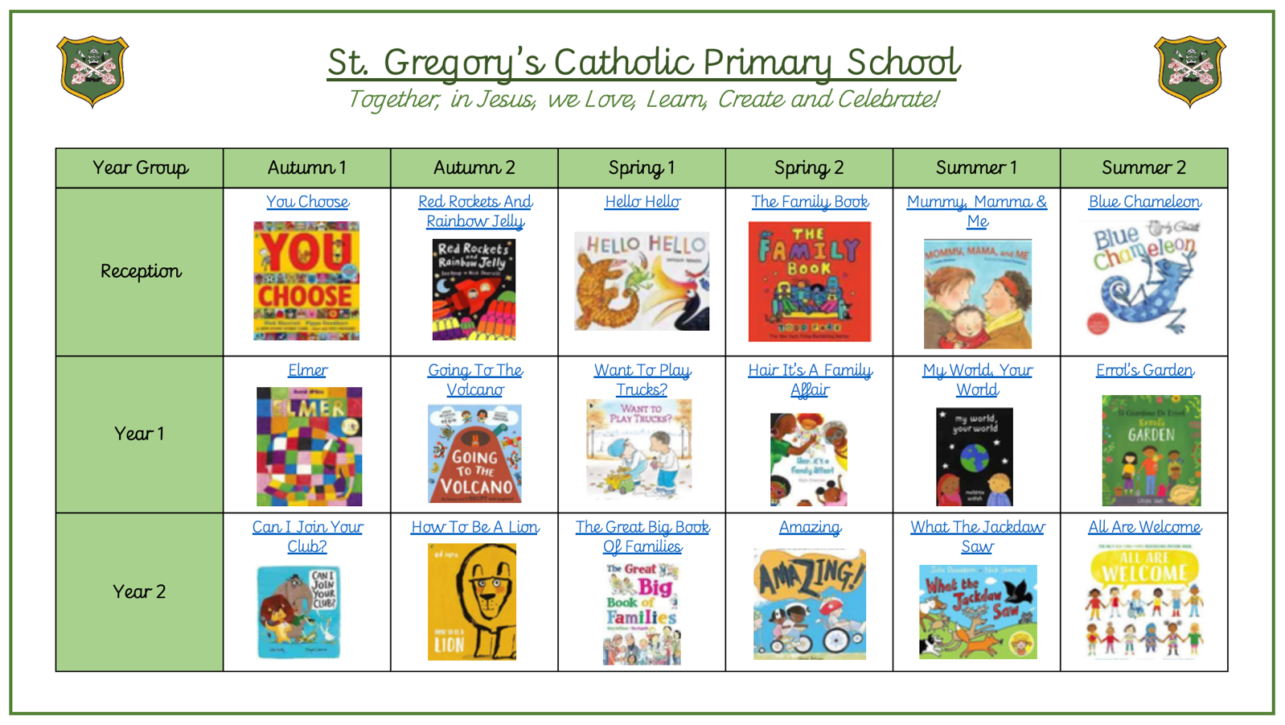
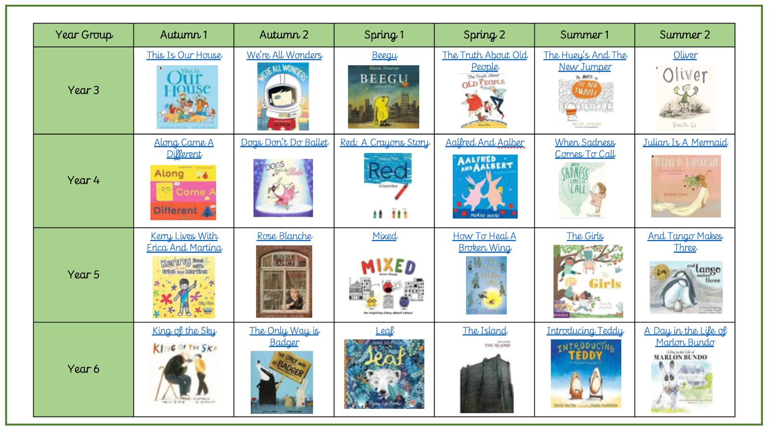

EYFS
The aim in EYFS is to introduce the ‘No Outsiders’ ethos using very simplistic language: we are all different and we are all friends. The key message is that “it’s ok to be you and you may be different to me, but that’s ok too.”
You Choose encourages children to choose their favourite place to live, favourite transport, favourite food etc and shows that we all like different things. This is explored further in Red Rockets and Rainbow Jelly, where characters Nick and Sue are shown liking different things throughout the book, but conclude by saying they like each other. Hello Hello shows different animals with a range of shapes and colours who all say ‘hello’ and no one is left out. The Family Book shows children that there are many types of family – and then we draw our own family! Mommy, Mama and Me allows children to understand some families have two mums (or two dads); we talk about the things Mommy and Mama do with their child and ask if our own families do similar things (go to the park, drink juice, kiss goodnight). Finally, Blue Chameleon shows a lonely chameleon trying to make friends by changing shape and colour; he thinks you have to look like someone else to be friends. At the end, Chameleon realises you can be yourself and you don’t have to change.

Year 1
In Year, 1 we develop the understanding of difference to consider ways in which
we might be different and how that can sometimes make us feel. The classic story of Elmer shows an elephant who decides to hide his difference but realises at the end that he should celebrate it. Going to the Volcano takes the children on a joyful expedition to an erupting volcano, and is chosen for its perfect call-and-response narrative and obvious role-play opportunity. The images show a huge range of different characters working together so that no one is left out. Want to Play Trucks? focuses on conversations between Jack and Alex, one of whom likes to play with dolls and the other with trucks. “You can’t wear a tutu and drive a crane,” argues Jack, and his reasoning is that, “It wouldn’t fit in the driver’s seat.” A compromise is made where the doll wears dungarees instead and then Jack and Alex go for an ice cream. This book teaches children to find solutions to conflict and subtly explores gender expectations at the same time. Hair, it’s a Family Affair! encourages children to celebrate their family and ways their family might be different. The family in the story (who happen to be African Caribbean) have different hair and the character is proud to belong. My World, Your World explores ways two children are different before finding a way they are similar. Finally, Errol’s Garden is a simple celebration of teamwork in which the main character knocks on his very diverse set of neighbours’ doors asking for help and everyone joins in!

Year 2
Can I Join Your Club? explores how Duck feels when animals exclude him from their clubs for not being like them. Duck sets up his own club and everyone is welcome, regardless of the animal noises they make. How to be a Lion shows children that not all lions behave in the same way. Leo is gentle and makes friends with a duck. This book explores peer pressure to behave in a certain way as the other lions tell Leo to be ‘more lion’. Children are encouraged to empathise with Leo and find a solution. The Great Big Book of Families raises awareness of diversity in the UK today; there are families represented but there are also houses, schools, jobs, festivals. It’s a books that introduces the word ‘diversity’ and its meaning. Amazing is a snapshot of friendship where the main character uses a wheelchair but the disability is never mentioned, allowing us to demonstrate it’s not an issue. What the Jackdaw Saw is a subtle way to promote awareness of communication needs, as to ensure all the animals can understand him, the Jackdaw learns to sign with his wings. Finally, All Are Welcome shows us a diverse class of children with diverse families who come to school, where everyone is welcome.

Year 3
This is Our House tells the story of George who shuts people out and gives reasons why: because they wear glasses, because they are girls, because they like tunnels. When it is pointed out to George that he has red hair and could also face discrimination, the penny drops – “This house is for everyone!” he says. We Are All Wonders is a story about a boy with facial disfigurement who is bullied and dreams of running away. ‘What would happen in our school?’ the children are asked to consider. ‘What would we say if we heard someone being unkind?’ The Bad Seed is a book that explores mental health and consequence of actions. The seed character is ‘bad’, but clearly the character is also very unhappy and we find out why as the story unfolds. By talking about his feelings, the bad seed decides to make a change in his life; it’s not easy but he takes it ‘one day at a time’. We talk about recognising feelings and finding strategies to deal with them when we feel overpowered by them. Stereotypes are explored in The Truth About Old People: what is a stereotype, how do we recognise a stereotype, and what can we do if we hear someone being discriminatory? The New Jumper introduces the Hueys – a quirky group of characters who are all the same, but one day Rupert knits an orange jumper. This causes much consternation and Rupert is treated as an outsider until Gillespi also wears an orange jumper. Gradually the Hueys learn it’s ok to be different. The final Year 3 book is Oliver, raises discussion about inclusion, individuality and belonging by following the story of Oliver, a little boy who feels different from others around him.

Year 4
Along Came a Different provides opportunity to discuss attitudes towards race and racism – the red shapes don’t like the blue shapes, who in turn don’t like the yellow shapes or the red shapes. At the key point of the story, the shapes draw up a set of segregation rules. The children discuss what they think of these rules. How can we rewrite them? Dogs don’t do Ballet teaches children to go for their dreams. Everyone tells a dog that he can’t be a ballerina, but he proves in the end that you can be what you want to be. In Red: A Crayon’s Story, a crayon who looks red can only colour in blue. This is very distressing for him as he knows he should be red, but he cannot get it ‘right’. For us this tale is a fantastic stimulus for discussion about identity and expectations, and for teaching children to be who they are. Aalfred and Aalbert gently shows how two aardvarks get together, helped by a small blue bird. Some children may realise the aardvarks in the story are two males, but that is not the focus of the story; rather, the focus is recognising loneliness, choosing to help others, finding common ground and understanding how companionship affects mental health. When Sadness Comes to Call picks up from The Bad Seed and explores further how to recognise feelings of sadness and their impact. The lesson plan focus is on good mental health and how it can be achieved. Julian is a Mermaid tells the story of a small boy wanting to be a mermaid. The key to the story is Nan’s attitude to her grandson; the reader is led to believe she is going to tell him off for dressing up, but instead she supports and helps him. It is a heart-warming story of difference and acceptance.

Year 5
Kenny Lives with Erica and Martina is a book that that focuses on attitudes towards LGBT people and homophobia to tell a story of a family who are literally made into outsiders when a wall is built to block them from the street. The ending is thought- provoking and enables the children to ask questions about discrimination and form responses. Rose Blanche follows a young girl living in Nazi-occupied Poland as she discovers a concentration camp outside her town with people wearing yellow stars on their jackets. Rose decides to help them. Mixed leads on from Along Came a Different in Year 4, but this time rather than just writing a set of rules to segregate, the colours construct physical walls and fences to separate themselves. When two different colours fall in love, their example serves as a force to alter perceptions. How to Heal a Broken Wing is an Amnesty International-endorsed book that shows a boy choosing to help a fallen bird; he is the only one to stop and help. We return to the concept first raised in Year 3 of choosing to be (or not to be) a bystander. The Girls focuses on positive representation of different gender, but also provides a stimulus for discussing friendship and recognising the importance of companionship. The story therefore offers opportunities for discussion of mental health. And Tango Makes Three is a story about a loving family of penguins adopting a chick, and the family happens to consist of two male parents.

Year 6
The Year 6 books have a theme of acceptance. King of the Sky explores feelings of being an outsider from the perspective of a young refugee boy. He forms a friendship with an elderly man who teaches the boy to work with homing pigeons. Through the pigeons, the boy learns to feel a sense of belonging. The Only Way is Badger tells the story of a badger building a wall across the forest and instructs the other animals to be ‘more badger’. If they fail, they are thrown over the wall. The ending of the story provides much material for discussions about conciliatory behaviour and consequences of actions. Leaf describes fears about the unknown and a lack of confidence to find out. A polar bear arrives on an island and rather than talking to him, the other animals hide and talk about him. This theme is revisited in The Island, which is a study into the control one group of people can have over another and the dire consequences of unchecked prejudice. Introducing Teddy is a tale of a teddy bear who comes out as trans halfway through the story. All of teddy’s friends accept her as Tilly, no one questions it, and this is the key focus of the text. The final book in the scheme, A Day in the Life of Marlon Bundo provides an opportunity to talk about democracy, prejudice and LGBT equality. A rabbit in the white house wants to marry another male bunny and while all the other animals celebrate the wedding, the leader of the animals says two male bunnies marrying is against the law. The animals have a vote to see if the law should be changed. The focus of the text is how democracy works.

